Contents

Mood board 2

Nav bar 2

Facebook 2

CD-keys 3

Content 4

Facebook 4

CD-Keys 5

Footer 6

Website plans 6

Plan1 6

Nav bar interaction 6

# Mood board

## Nav bar

### Facebook

HOVER EVENT ON ICON:

HOVER EVENT ON ICON:

STATIC:



CLICK EVENT:

HOVER EVENT ON ICON:

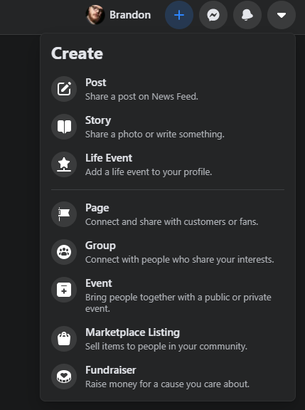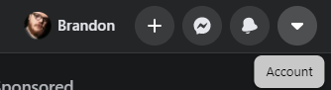

#### Consensus

Facebook has no animations for their navigation, it keeps it simple doesn’t complicate the coding process, however it is quite boring. The colour of the navigation and its drop downs are the same colour and styling keeping it coherent. Each drop down has icons to help further give the idea of what the function is. They follow the styling of Icon on the far left, Bold title(what it is), sub title not bold(what it does). Facebook also has a dark mode which is brilliant for the people of the modern world who don’t want to be blasted by white light. All the main content(posts) are centred perfectly, they also have a heading and a footer to help centre the content in a more streamlined way:

### CD-keys

STATIC:



HOVER EVENT ON ICON:

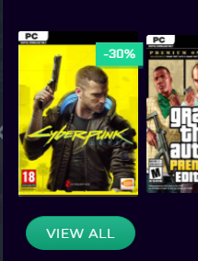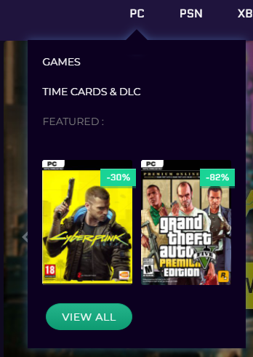

Image zooms slightly

Button brightens up

HOVER EVENT ON SUB ITEM(s):

#### Consensus

its simplistic and easy to use. You don’t need to click anything for it to showcase content so it can easily help those less able and less used to websites like this. The interact-ability with the animations gives the user feedback helping re-enforce what is happening. The colour scheme is pleasing to the eyes and makes the content pop out more than something on a white background would. The deep colour makes more things pop out and allows for a wider range of colours to be used

Main view:

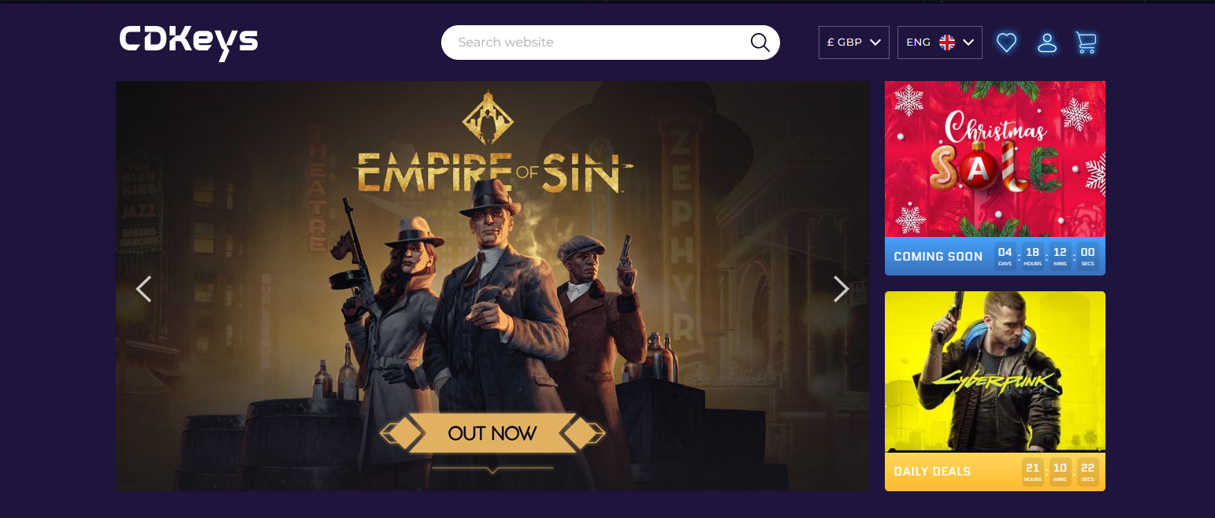

The main content here gives us more leverage to what we can have our user see first when they enter the site. Here we can see a selection of games on an automatic scroll, we can also click the arrows, the arrows light up on their hover event. The grid like approach gives it a better aesthetic feeling

## Content

### Facebook

This section is the post header, it shows the title name(poster) and gives more style to the post, makes it stand out from other posts, it lets me realise “this is a post” and it’s not just a flat looking image on a background, the header and footer give more depth



This is the actual content, the size of this section depends on the post itself. The padding options for this could be good for our site to display store items but its best to look at store sites to see their ideas

This is the footer of the content. It helps pad out the image and gives us more functionality options

#### Consensus

The content is cantered nicely allowing for content to be on the left and right of the page that isn’t scrollable, making things more accessible but that may not be needed for our site.

### CD-Keys

Item list separated in sub sections:

Coming soon –

The coming soon section lets users pre order items making sales occur before product release, giving possible chance to more sales. With them seeing a taster of the new item, they may be more likely to purchase it.

Best sellers -

The best sellers section is a very good option in my eyes, it shows customers the best products that’s there, the better our products on show, the more likely they are going to be bought. If they are high in demand, that fact alone is going to get people wanting to check it out which in turn can add to sales.

Trending-

This section showcases what’s popular among users on the site and may help coincide new items to appear on our best sellers section

Design –

Personally, I think the design is okay but the way all the products are in a uniform way makes it harder for me personally to find what I want. However, this is a perfectly valid approach to what can be used for Jays site. I like the neon design of separating things, it gives the sight a more night time modern esc feeling. I would personally have coming soon at the bottom as they may be irrelevant products to our user because there’s nothing to suggest they would want it other than its new. Whereas with the best sellers and trending, they’re what’s popular among a wide range of people making it more likely catered for our user

#### Consensus

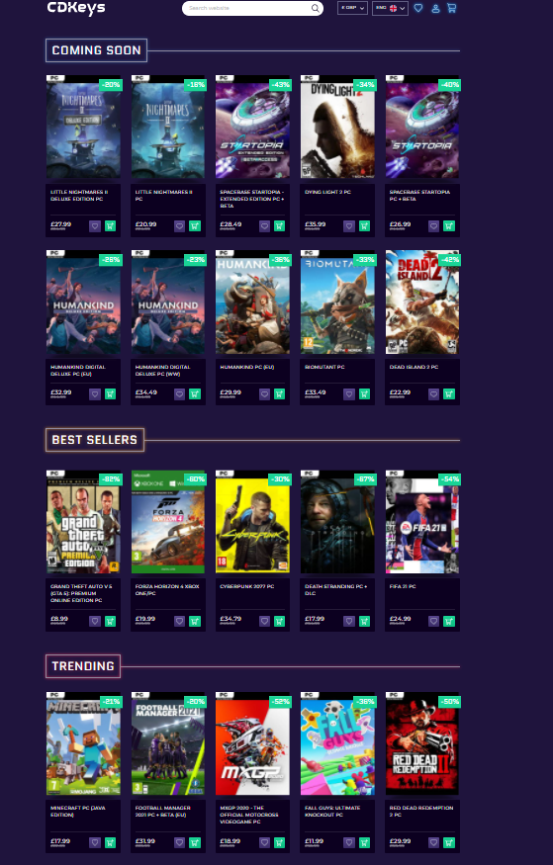

## Footer

### CDkeys

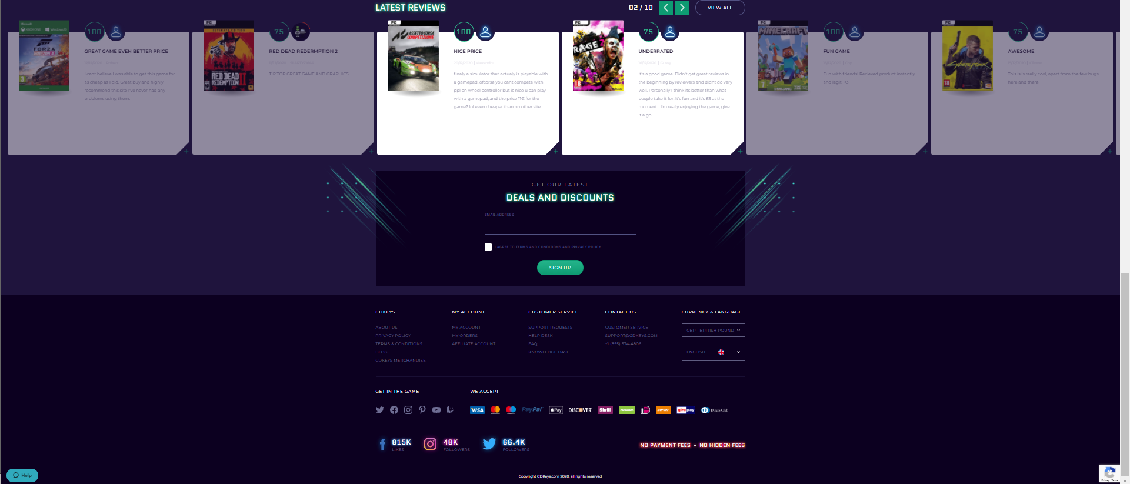

#### Consensus

One aspect I really like is recent reviews, this can help showcase on our front page what people like and the rating they give that specific item. This can really help us sell more items of specific categories due to these reviews. However, I am not sure how easy this will be to implement because they will need to be client submitted so they’ll come in at random points and will have to work with our HTML and CSS. I do like the option to sign up for a newsletter on the bottom, its out of the way and isn’t begging the user to sign up. Also, there’s all the important information at the bottom out of the way of our selling content, its not relevant for buyers but more customers who need more than our products, this section could be implemented in a hamburger menu or something like that to clean up the website.

# Website plans/ Functional design

